This is a test document

This is a test document

This is a test document

This is a test document

This is a test document

This is a test document

This is a test document

This is a test document

This is a test document

This is a test document

This is a test document

This is a test document

This is a test document

This is a test document

This is a test document

This is a test document

This is a test document

This is a test document

This is a test document

This is a test document

This is a test document

This is a test document

This is a test document

This is a test document

This is a test document

This is a test document

This is a test document

This is a test document

This is a test document

This is a test document

This is a test document

This is a test document

This is a test document

This is a test document

This is a test document

This is a test document

This is a test document

This is a test document

This is a test document

This is a test document

This is a test document

This is a test document

This is a test document

This is a test document

This is a test document

This is a test document

This is a test document

This is a test document

This is a test document

This is a test document

This is a test document

This is a test document

This is a test document

This is a test document

This is a test document

This is a test document

This is a test document

This is a test document

This is a test document

This is a test document

This is a test document

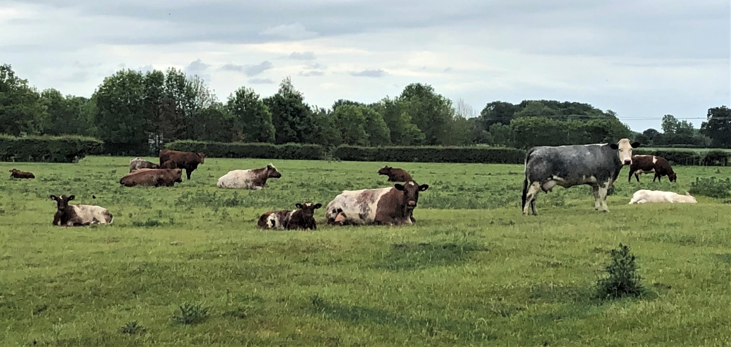

This is a test document